***+ANUDIP FOUNDATION***

A Project Report on

**ART GALLERY MANAGEMENT SYSTEM**

By

Batch: ANP-D0453

Student ID: AF0477120

Name: Aboli Birajdar

**Under the Guidance of**

Mrs. Rajshri Chandrabhan Thete

ART GALLERY MANAGEMENT SYSTEM

Introducing our Java-based Art Gallery Management System (AGMS):

In today's digital age, the demand for automated systems in various industries is growing rapidly, and the art world is no exception. An **Art Gallery Management System** is a software application designed to simplify and automate the operations of an art gallery. It provides a centralized platform for managing artworks, artists, categories, customers, orders, and payments efficiently.

This system aims to bridge the gap between artists and art enthusiasts by offering a user-friendly interface for browsing, purchasing, and managing art pieces. It allows administrators to easily maintain records, track sales, and monitor gallery activities. By using technologies like **Java, Hibernate, JDBC, and MySQL**, the project ensures robust functionality, secure data handling, and smooth database interactions.

The purpose of this project is to create a reliable and scalable solution that enhances the management of art galleries while promoting digital transformation in the art sector.

**Entities:**

* Admin
* Art
* Artist
* Customer
* Category
* Order
* Payment

**ATTRIBUTES OF ENTITIES:**

1. **Admin**

* Attributes:
* Admin_id (primary key)
* Admin_name
* Contact
* Email
* Password

1. **Art**

* Attributes:
* Art_Id (primary key)
* Type
* Description

1. **Artist**

* Attributes:
* Artist_d (primary key)
* Category_Id (Foreign Key)
* Age
* Birthplace
* Style

1. **Customers**

* Attributes:
* Cust_Id (primary key)
* Name
* Contact
* Address

1. **Category**

* Attributes:
* Category_Id(primary key)
* Name

1. **Orders**

* Attributes:
* Order_Id (primary key)
* Confirmation
* Date
* Cust_Id(foreign key)
* Price
* Phone

1. **Payment**

* Attributes:
* Pay_Id(primary key)
* Amount
* Method
* Date
* Order_Id(foreign key)
* Description

**ENTITY RELATIONSHIP DIAGRAM – ART GALLERY MANAGEMENT SYSTEM**

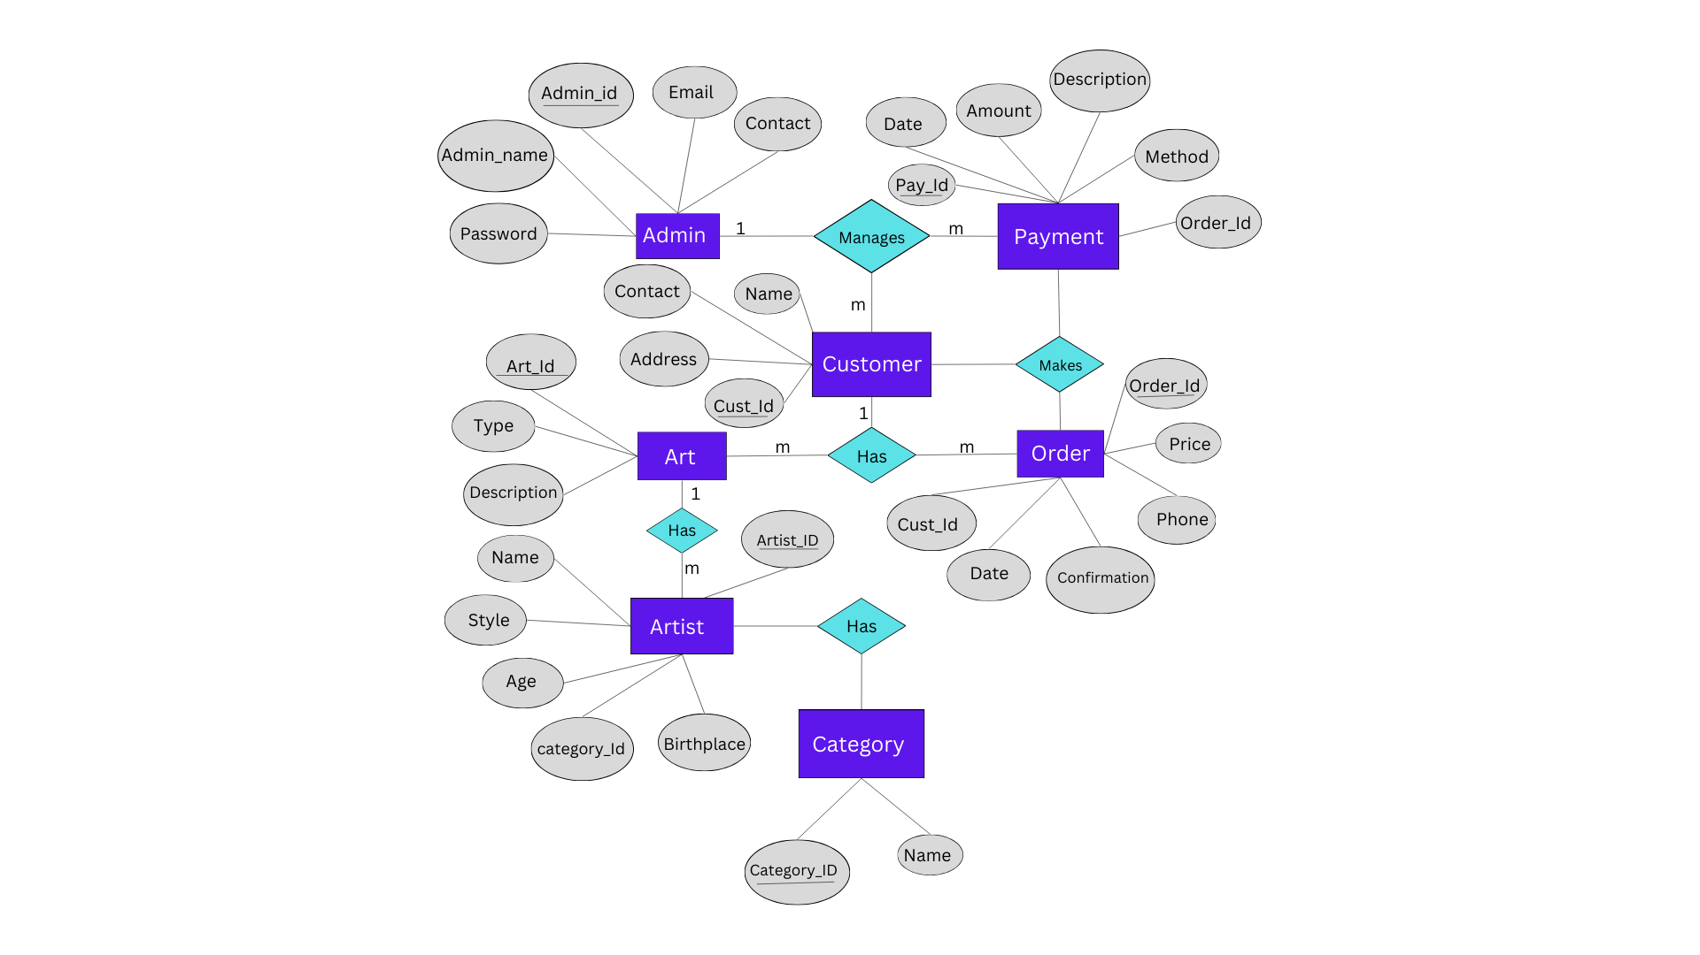

**CONCLUSION:**

The Art Gallery Management System has been successfully developed to streamline and digitalize the operations of an art gallery. This system offers a robust platform to manage artists, customers, artworks, categories, orders, and payments efficiently. By integrating technologies like Java, Hibernate, JDBC, and MySQL, the system ensures smooth data handling, secure transactions, and a user-friendly interface. This project not only enhances accessibility for art enthusiasts and buyers but also provides a structured backend for administrators to maintain records and monitor gallery activities. The relational database design and the use of object-oriented principles help ensure scalability and maintainability of the application. Overall, the Art Gallery Management System serves as a practical and effective solution to modernize gallery operations, promote artists' work, and improve user engagement in the digital era.

**DATABASE CREATION QUERY:**

**mysql> use artgallery;**

**Database changed**

**mysql> CREATE TABLE Admin (**

**-> Admin_id VARCHAR(15) PRIMARY KEY,**

**-> Admin_name VARCHAR(50),**

**-> Password VARCHAR(50),**

**-> Email VARCHAR(100),**

**-> Contact VARCHAR(15) );**

**Query OK, 0 rows affected (0.08 sec)**

**mysql> CREATE TABLE Customer (**

**-> Cust_Id VARCHAR(15) PRIMARY KEY,**

**-> Name VARCHAR(50),**

**-> Contact VARCHAR(15),**

**-> Address VARCHAR(255)**

**-> );**

**Query OK, 0 rows affected (0.03 sec)**

**mysql> CREATE TABLE Category (**

**-> Category_ID VARCHAR(15) PRIMARY KEY,**

**-> Name VARCHAR(50)**

**-> );**

**Query OK, 0 rows affected (0.03 sec)**

**mysql> CREATE TABLE Artist (**

**-> Artist_ID VARCHAR(15) PRIMARY KEY,**

**-> Name VARCHAR(50),**

**-> Birthplace VARCHAR(100),**

**-> Age INT,**

**-> Category_Id varchar(15),**

**-> FOREIGN KEY (Category_Id) REFERENCES Category(Category_ID)**

**-> );**

**Query OK, 0 rows affected (0.07 sec)**

**mysql> CREATE TABLE Art (**

**-> Art_Id VARCHAR(15) PRIMARY KEY,**

**-> Name VARCHAR(50),**

**-> Type VARCHAR(50),**

**-> Description TEXT,**

**-> Style VARCHAR(50),**

**-> Category_Id VARCHAR(15),**

**-> Artist_ID VARCHAR(15),**

**-> FOREIGN KEY (Category_Id) REFERENCES Category(Category_ID),**

**-> FOREIGN KEY (Artist_ID) REFERENCES Artist(Artist_ID)**

**-> );**

**Query OK, 0 rows affected (0.10 sec)**

**mysql> CREATE TABLE Orders (**

**-> Order_Id VARCHAR(15) PRIMARY KEY,**

**-> Cust_Id VARCHAR(15),**

**-> Date DATE,**

**-> Price DECIMAL(10,2),**

**-> Phone VARCHAR(15),**

**-> Confirmation VARCHAR(50),**

**-> FOREIGN KEY (Cust_Id) REFERENCES Customer(Cust_Id)**

**-> );**

**Query OK, 0 rows affected (0.07 sec)**

**mysql> CREATE TABLE Payment (**

**-> Pay_Id VARCHAR(15) PRIMARY KEY,**

**-> Amount DECIMAL(10,2),**

**-> Date DATE,**

**-> Description TEXT,**

**-> Method VARCHAR(50),**

**-> Order_Id VARCHAR(15),**

**-> FOREIGN KEY (Order_Id) REFERENCES Orders(Order_Id)**

**-> );**

**Query OK, 0 rows affected (0.06 sec)**

**mysql> show tables;**

**+-------------------------+**

**| Tables_in_artgallerymng |**

**+-------------------------+**

**| admin |**

**| art |**

**| artist |**

**| category |**

**| customer |**

**| orders |**

**| payment |**

**+-------------------------+**

**7 rows in set (0.00 sec)**